American Society for Precision Engineering

Template for ASPE short and extended abstracts

Emily Roebling¹, Alexander G. Bell², Edwin P. Hubble²

¹Affilitation, Address

²Affilitation, Address

- Instructions
This document provides formatting requirements for submission of an ASPE Annual Meeting abstract and should be used directly as the template for abstract preparation. Abstract submissions must be in pdf format, follow the styles in this template and be two pages for short abstracts and typically four to six pages for the full extended abstract. Using the styles is important to provide document navigation and maintain consistent formatting.This paragraph is ‘First paragraph’ style in the ‘Style palate’ under the ‘Home’ tab.

The paper size should be 8.5” x 11” (216 by 279 mm US letter size) with 0.75” (19 mm) margins on all sides. For authors using the A4 paper size (European, Asian and Latin American) in LaTeX, there is a button (dvi2pdf) used to create a pdf file in LaTeX installations based on WinEdt. To instruct dvipdfm to use US letter size paper by default, change the default paper size line in the config file in [TEXMF]\dvipdfm\config.
Paper text should begin one line below the author list and be single spaced, 10-point Arial font using justified alignment in a two column format. Each column should be 3” (76.2 mm) wide with a 0.5” (12.7 mm) spacing between columns. Spacing between paragraphs should be one line. Do not use page numbers, headers, footers, or footnotes within the manuscript.
References should be in the same typeface as the text and appear at the end of the paper arranged in order of appearance. Within the text, they should be numerically identified using closed brackets, for example [1]. Use the “Vancouver” numbering format described at http://www.icmje.org and demonstrated at the end of this document.
- PAPER TITLE AND AUTHOR(S)
Author name(s) should consist of first (given) name, middle initial, and last (family) name. All author names and affiliations should be 12-point Arial bold, upper and lower case letters, and centered. All authors should be listed on the same line with their affiliations identified by numeric superscripts at the end of the name. [In the case of a single author, do not use a superscript.] Author affiliation(s) should consist of the following, as applicable:

- department or division name
- company or university
- city, state or province, and country
More than two author affiliations may be listed in double columns.
- FORMATTING
This document provides formatting requirements for submission of an ASPE Annual Meeting abstract and should be used directly as the template for abstract preparation. Abstract submissions must be in pdf format and follow this template.
The paper size should be 8.5” x 11” (216 by 279 mm US letter size) with 1” (25.4 mm) margins on all sides. For authors using the A4 paper size (European, Asian and Latin American) in LaTeX, there is a button (dvi2pdf) used to create a pdf file in LaTeX installations based on WinEdt. To instruct dvipdfm to use US letter size paper by default, change the default paper size line in the config file in [TEXMF]\dvipdfm\config.
Paper text should begin one line below the author list and be single spaced, 10-point Arial font using justified alignment in a two column format. Each column should be 3.125” (79.4 mm) wide with a 0.25” (6.35 mm) spacing between columns. Spacing between paragraphs should be one line. Do not use page numbers, headers, footers, or footnotes within the manuscript.
References should be in the same typeface as the text and appear at the end of the paper arranged in order of appearance. Within the text, they should be numerically identified using closed brackets, for example [1]. Use the “Vancouver” numbering format described at http://www.icmje.org and demonstrated at the end of this document.
To add a reference, open the ‘references’ tab and
- PAPER TITLE AND AUTHOR(S)
The paper title should start 1” (25.4 mm) from the top of the page and be 14-point bold, Arial font in all capital letters. The title should be centered on the page. One line space should separate the title from the author listing(s).
Author name(s) should consist of first (given) name, middle initial, and last (family) name. All author names and affiliations should be 12-point Arial bold, upper and lower case letters, and centered. All authors should be listed on the same line with their affiliations identified by numeric superscripts at the end of the name. [In the case of a single author, do not use a superscript.] Author affiliation(s) should consist of the following, as applicable:
- department or division name
- company or university
- city, state or province, and country
More than two author affiliations may be listed in double columns.
- STYLES
This template contains the necessary styles to create title, author list, headings, figures, tables, and references. These styles can be viewed by opening the syle pane as shown in FIGURE 1. After opening the styles pane you should see the available styles list shown in FIGURE 2. Links to figures, headings and tables can be inserted using the ‘cross-reference’ section in the References tab. .

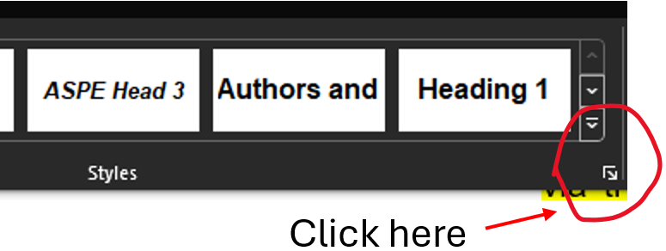
FIGURE 1: Opening the style pane

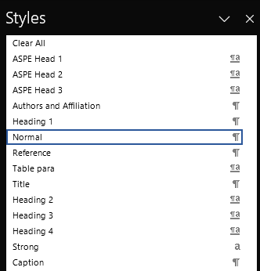
FIGURE 2: The available styles.
- TEXT HEADING #1
The primary text heading should be 10-point Arial bold, all capital letters, flush left with the margin. If the heading is more than one line, the following lines should also be flush left. The spacing to the next heading should be one line (10pt). To create this first-level text heading #1, select ASPE HEAD 1 style, then go to multilevel list shown in Figure 3 and choose the list highlighted in a red box. Pressing the Tab key once will create the second level heading #2, and pressing it again will create a third-level heading #3.

  - Text Heading #2
The first sub-heading should be 10-point Arial bold, upper and lower case letters, and underlined. The heading is flush left, and the spacing to the next heading is one line.
  - Text Heading #3
The third level of heading should be 10-point Arial bold, upper and lower case letters. The heading is flush left, and the spacing to the next heading is one line.
Figure 3: Selecting the multilevel list

- TABLES AND FIGURES
All figures, tables and photos may be in color. Text within figures should have a font size of not less than 8-point. Photographs should be scanned at 144 dots per inch (dpi) and inserted as graphic objects. Figure and table captions should be numerically labeled in consecutive order. Caption text should follow the identification and use 10-point Arial font with upper and lower case letters, italicized, and justified, use the caption style to achieve this format, see FIGURE 2. If necessary, tables and figures may be inserted using a single column format.

TABLE 1: The table identification (e.g., TABLE 1) should be 10-point Arial, all capitals, italicized, and end with a period. It should be placed above the table.
Value 1 | Value 2 | Value 3
1 | 0.1 | 0.6
2 | 0.5 | 1.5

FIGURE 4 The figure identification (e.g., FIGURE 1) should be 10-point Arial, all capitals and end with a period. It should be placed below the figure. Use the caption style to produce a caption.
- PAPER SUBMISSION
Please submit your abstract as an Adobe Acrobat PDF file.

- Before submitting your PDF abstract (maximum two pages), ensure that all symbols were coverted appropirately from your word processing software into the PDF file.
- Before submitting your PDF abstract ensure that the PDF file contains all the required formatting outlined in this template. Please do not include page numbers, headers, footers or footnotes.

- PROTECTED DOCUMENTATION
It is very important that you not send abstracts that are password protected or otherwise secured. All reviewers must have file access for proper consideration.
- SHORT Abstract Submission
Short abstracts must be submitted in PDF format via the on-line submission portal on the ASPE website (www.aspe.net). Submission instructions are available on the website.

REFERENCES
- Lindeke R, Schoenig F Jr, Khan A, Haddad J. Machining of α,β-Titanium with Ultra-High Pressure Through the Insert -rfderence’ feature in the captions section within the ‘References’ tab.North American Manufacturing Research Institution of SME. 1991; 19: 154-161.
- Trigger K, Chao B. An Analytical Evaluation of Metal Cutting Temperatures. ASME Transactions, Journal of Engineering for Industry. 1951; 73: 57-68.
- Ulsoy A, DeVries W. Microcomputer Applications in Manufacturing. John Wiley and Sons, Inc. New York: 1989.

